CONNECTED, LEVEL 4 2015, Is That So?  A Sinking Feeling  by Ken Benn  Overview  The budding mathematicians in Mr Tuala’s class have just lost a competition to design boats that would float downstream, carrying a load of marbles. Through a series of experiments and mathematical activities involving measurement, they explore concepts about “density”, “mass”, and “volume” and apply them to the design of boats that really will float.  A Google Slides version of this article is available at www.connected.tki.org.nz. |  |  | 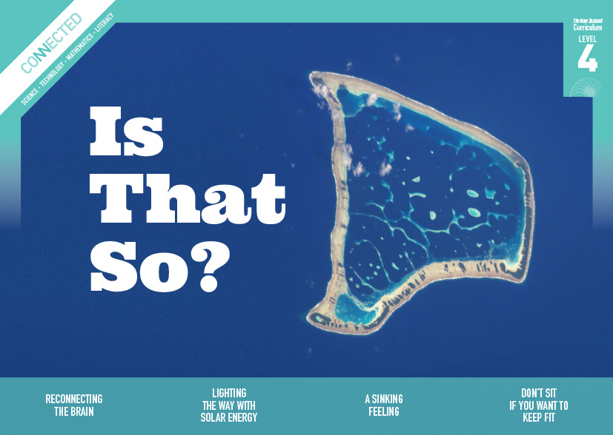  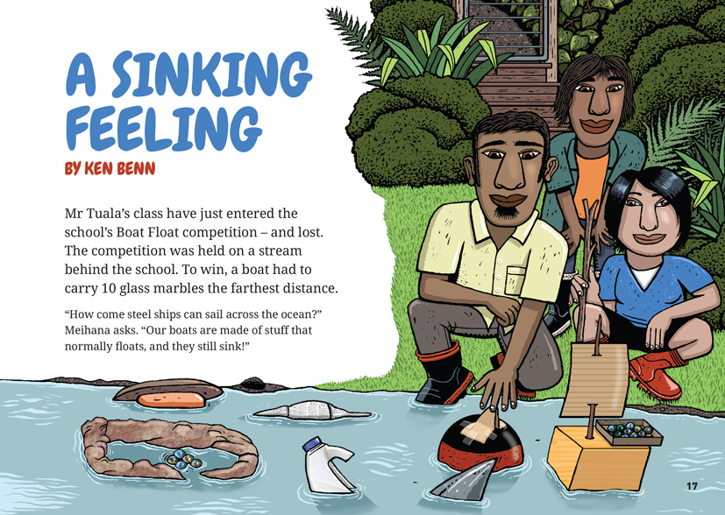
Science capability: Critique evidence |  | Text characteristics

Science knowledge is based on data derived from direct or indirect observations of the natural physical world. An inference is a conclusion drawn from those observations; it is the meaning you make from the observations. Understanding the difference between an observation and an inference is an important step towards being scientifically literate.  Being ready, willing, and able to critique evidence is also an important step towards being scientifically literate. Students must be able to assess the quality and reliability of both the observations (data) and the inferences made from those observations. In order to know what sorts of questions to ask to evaluate the trustworthiness of data, students need both methodological knowledge (how data is generated and collected) and statistical knowledge (how data is collated and analysed). For more information about the “Critique evidence” science capability, go to http://scienceonline.tki.org.nz/Introducing-five-science-capabilities/Critique-evidence |  | - The structure of the text as a narrative with a considerable amount of direct speech.  - Pictures and diagrams that clarify and elaborate on the text and require interpretation.  - Mathematical vocabulary and terminology.

Curriculum context

SCIENCE
NATURE OF SCIENCE: Investigating in science  Achievement objectives  L4: Students will build on prior experiences, working together to share and examine their own and others’ knowledge.  Students will ask questions, find evidence, explore simple models, and carry out appropriate investigations to develop simple explanations. |  | PHYSICAL WORLD: Physical inquiry and physics concepts  Achievement objective  L4: Students will explore, describe, and represent patterns and trends for everyday examples of physical phenomena, such as movement, forces, electricity and magnetism, light, sound, waves, and heat. For example, identify and describe the effect of forces (contact and non-contact) on the motion of objects; identify and describe everyday examples of sources of energy, forms of energy, and energy transformations. |  | Key Nature of Science ideas  Scientists:  - evaluate the trustworthiness of data by asking questions about investigations carried out by others  - undertake more than one trial to provide sufficient evidence to support a theory  - replicates investigations to critique the evidence/data provided by other scientists  - check that there are enough samples to reliably establish a conclusion or theory  - look carefully at the way data has been collected when they consider investigations done by others.  Key science idea  - An object floats if it is less dense than the water it is floating in.

ENGLISH

READING  Ideas  Students will show a developing understanding of ideas within, across, and beyond texts. |  | INDICATORS  - Makes meaning of increasingly complex texts by identifying and understanding main and subsidiary ideas and the links between them.  - Makes connections by thinking about underlying ideas within and between texts from a range of contexts.  - Recognises that there may be more than one reading available within a text.  - Makes and supports inferences from texts with increasing independence. |  | THE LITERACY LEARNING PROGRESSIONS  The literacy knowledge and skills that students need to draw on by the end of year 8 are described in The Literacy Learning Progressions.

TECHNOLOGY
NATURE OF TECHNOLOGY: Characteristics of technological outcomes  Achievement objective  L4: Students will understand that technological outcomes can be interpreted in terms of how they might be used and by whom and that each has a proper function as well as possible alternative functions. |  | TECHNOLOGICAL KNOWLEDGE: Technological modelling  Achievement objective  L4: Students will understand how different forms of functional modelling are used to explore possibilities and to justify decision making and how prototyping can be used to justify refinement of technological outcomes.  TECHNOLOGICAL KNOWLEDGE: Technological products  Achievement objective  L4: Students will understand that materials can be formed, manipulated, and/or transformed to enhance the fitness for purpose of a technological product. |  | Key technology idea  - The technologist considers the performance properties of materials when selecting them for a technological outcome.

MATHEMATICS AND STATISTICS
GEOMETRY AND MEASUREMENT: Measurement  Achievement objective  L4: Students will use appropriate scales, devices, and metric units for length, area, volume and capacity, weight (mass), temperature, angle, and time. |  | Key mathematics idea  - Organising data and looking for patterns and trends can reveal useful information.

Critiquing evidence

The science capability “Critique evidence” is about students evaluating the quality of the data supporting a scientific claim or idea (http://scienceonline.tki.org.nz/Introducing-five-science-capabilities/Critique-evidence).
Scientists use empirical evidence to develop theories about how the world works.
- Empirical evidence is data gathered from observations, experiments, and investigations.
- Scientific claims are only as dependable as the evidence on which they are based.
- Scientists design their investigations carefully to ensure that the data they gather is both reliable and valid. Valid data is data that measures what it is supposed to measure – it answers the research question. Reliable data is dependable and consistent. Replicating the experiment and getting the same results makes us more confident the data is reliable.
- To gather high-quality evidence that is reliable and valid, scientists measure accurately, keep conditions the same or control variables that might influence measurements or observations, repeat tests or investigations many times, investigate multiple examples, and/or use statistical sampling techniques to make their observations or data as representative and accurate as they can.
Students should be critiquing and evaluating the quality of data gathered from their own investigations by:
- engaging in a range of investigation types, exploring, comparing, classifying, identifying, seeking patterns, using models, making things to test ideas, and investigating systems so that they learn different ways to gather different types of data
- identifying ways to make the data they collect in their own investigations as accurate and reliable as possible
- suggesting and developing ways to control conditions or variables or keep things fair, repeating observations or measurements or tests, and developing appropriate sampling methods
- applying their developing understanding of statistics and probability (sampling, variability, randomness, and the exploration of relationships in multivariate data) when making decisions about sample size and repetitions and when working with their data.
Students should also be encouraged to look for, consider, and critique methods and data underpinning scientific claims made by others. This includes critically examining the appropriateness of methods and the quality of evidence used to develop scientific claims in the media and other sources.
Teachers can:
- help students to be more critical consumers of science information by being explicitly critical themselves
- support students to identify correlations as evidence of a potential relationship, but not necessarily cause and effect
- ask questions such as:
  - Would this always happen?
  - How sure are you of your measurements?
  - How many times should you repeat these tests/measurements?
  - Is this a fair result?
  - What may have influenced the data?
  - Was there a big enough sample?
  - Does the data match the claim?
  - How much variation is there in your results? Why might that be?
- support students to evaluate how data is presented; for example, if data is presented graphically, is this done appropriately or is it misleading? (This draws on another science capability, Interpret representations.)
- support students to apply their understanding of statistics and probability when considering claims, evidence, and data.
- establish a science classroom culture by:
  - modelling and encouraging a critical stance
  - encouraging students to consider the quality and interpretation of data underpinning scientific claims
  - using media headlines to introduce learning conversations and demonstrate the relevance of critiquing evidence to everyday life.
A range of questions and activities designed to get students to critique evidence is available on the Science Online website: http://scienceonline.tki.org.nz/Introducing-five-science-capabilities/Critique-evidence

Meeting the literacy challenges

The literacy demands of this text lies in locating, evaluating, and intepreting complex scientific and maths concepts and ideas relating to density within a narrative-style text. The interpretation and use of graphs and tables that provide additional information is required for students to gain a good understanding of the text.
The following strategies will support students to understand, respond to, and think critically about the information and ideas in the text. You may wish to use shared or guided reading, or a mixture of both approaches, depending on the reading expertise of your students and the background knowledge they bring to the text
After reading the text, support students to explore the activities outlined in the following pages

TEACHER resources

Want to know more about instructional strategies? Go to:
- http://literacyonline.tki.org.nz/Literacy-Online/Teacher-needs/Reviewed-resources/Reading/Comprehension/ELP-years-5-8
- “Engaging Learners with Texts” (chapter 5) from Effective Literacy Practice in Years 5 to 8 (Ministry of Education, 2006)
Want to know more about what literacy skills and knowledge your students need? Go to:
- http://literacyonline.tki.org.nz/Literacy-Online/Student-needs/National-Standards-Reading-and-Writing
- http://www.literacyprogressions.tki.org.nz
“Working with Comprehension Strategies” (chapter 5) from Teaching Reading Comprehension (Davis, 2007) gives comprehensive guidance for explicit strategy instruction in years 4–8.
Teaching Reading Comprehension Strategies: A Practical Classroom Guide (Cameron, 2009) provides information, resources, and tools for comprehension strategy instruction.

INSTRUCTIONAL STRATEGIES

FINDING THE MAIN IDEAS
Prior to reading, have the students SKIM the article to get the gist of the content/narrative and a sense of its purpose.
ASK questions to focus them on the relevant ideas:
Who are the people in this article? What are they doing?
What could the students do to design a boat to win the race?
What questions might they ask?
Where might they find information?
Who might be able to help them?
What experiments might they do?
DISCUSS the nature of inquiry in mathematics and science and have the students suggest the process that Mr Tuala’s class might follow. Co-construct a graphic organiser with the students on the whiteboard. You could support the students to construct their graphic organisers by giving them cards with the following statements. Some of the statements represent the phases of inquiry and some represent what we do during those phases. The students should separate the two types of card and put them into order. (The headings here are based on the statistical inquiry cycle exemplified in the CensusAtSchool materials.)
Problem
Define the problem
Think about how to answer the problem
Plan
Decide what to measure and how
Decide how to collect the data
Data
Gather data
Record data
Analysis
Sort data
Construct tables and graphs
Look for patterns
Generate hypotheses
Conclusion
Interpret data
Draw conclusions
Generate new ideas
Communicate ideas
Use the graphic organiser to SUMMARISE what happens as the students read. EXPLAIN that in real life, inquiries don’t always follow the same straight course, and the students should be prepared to modify the template they have created if necessary. Note that the class in the story made and tested a series of predictions, so some headings will be repeated.
Phases of inquiry | What happened in the story
Clarify that the author of this article attempts to make mathematical concepts accessible and interesting to the reader by communicating them through the interactions of a classroom of mathematics learners. DISCUSS the students’ response to this approach.
- What text type has the author used? Why do you think he chose this text type?
- How successful do you think the author is in communicating his ideas about mathematics? Does the form of the text as narrative help you to understand the mathematical ideas better? Or is it a problem?
- What are the grammatical features of direct speech? Where do you find the speech marks? Where do the commas go?
- How do you know who is talking when an author uses direct speech?

USING THE TABLES AND GRAPHS
Tell the students to discuss the tables on page 20. ASK them to discuss the following questions:
- What does the first table tell us?
- How would we explain it to someone else?
- How do we use this information?
- Why was a third column added to the second table?
- How does this information add to our understanding?
- Why is a table a good way of communicating this information?
Turn to the graph on page 21. In pairs, ask the students to identify the parts of the graph they can name and describe their purpose. ASK them:
- What does the blue line show us?
- What conclusions can we draw from this graph?
- Why is a graph a good way of communicating this information?

DEALING WITH MATHEMATICAL VOCABULARY
IDENTIFY the terms that may challenge students, for example: “weigh”, “weight”, “density”, “in relation to”, “grams”, “space”, “rate”, “weight to space rate”, “compare”, “cubic centimetres”, “weight per volume”, “predict”, “litre”, “mL”, “cm³”, “plot”, “data”.
PROMPT the students to work in small groups to construct definitions for each term, using their prior knowledge, information from the text, and classroom resources such as dictionaries. They could use a chart similar to this to think about and record definitions for unfamiliar words and phrases:
Word | What I think it means | Dictionary definition
Have them organise the terms into groups and illustrate them with an example that might include a sketch. DISCUSS the definitions, drawing out the idea that while many of them seem very familiar, there is a need to understand their precise meaning in the context of mathematics and science.

Teacher support
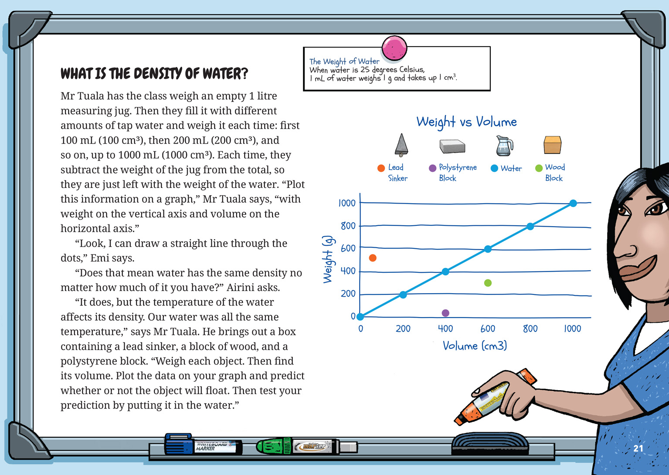 | Students use approximate scales and metric units for volume and capacity.  Students organise data to look for patterns and other useful information.  Students ask questions and explore simple models to develop explanations.

Learning activities
The following activities and suggestions are designed as a guide for supporting students to explore and develop understandings about the science capability “Critique evidence”. Some activities focus directly on the science capability. Other activities extend student content knowledge across the learning areas. You are encouraged to adapt these activities to support your students’ learning needs.

exploring the science

Activity 1: Float my boat
Reinforcing the learning
Reinforce the students’ understandings of the scientific and mathematical concepts in the text by having them replicate the experiments in the story, using materials from around the school. They should graph their results in a weight vs volume graph and then analyse the data. They should write a paragraph explaining how weight and density affect the design of boats and why they think Airini’s boat design was so successful.
Check that all the students have a clear understanding of the concepts of “density”, “weight”, and “volume”. If students are having difficulty, consider the following options to reinforce their understandings:
The article “How to Explain Density to Elementary Students” shows you how can explain these concepts through a simple experiment that you perform for the class (www.ehow.com/how_7706125_explain-density-elementary-students.html).
In the Science Learning Hub activity “Buoyancy in water”, students make a Cartesian diver. Extension ideas support them to explore what happens to the density of water when it is cooled or when salt is added (http://sciencelearn.org.nz/Contexts/The-Ocean-in-Action/Teaching-and-Learning-Approaches/Buoyancy-in-water).
Applying and extending the learning
Encourage the students to plan, design, and build boats and then have a competition similar to the one in the text. Consider making this a cross-curricular unit, integrating the suggested learning activities for literacy, mathematics, and technology.
Before the students commence their designs, introduce new and related concepts, drawing from one or more of the following suggestions. Have the students construct definitions for the new terms they learn, adding them to the class glossary.
Building Science Concepts Book 37 – Floating and Sinking: How Objects Behave in Water and Book 38 – Understanding Buoyancy: Why Objects Float or Sink contain activities that you could use to support the students to explore the notions of “displacement” (that an object floats when its weight is equal to the weight of the water it displaces) and “thrust” (that an object floats in water when the upthrust balances the object’s weight). These ideas are present in the story, but the terms are not used. Consider, in particular, Section Two, Activity 2 and Section Four, Activity 1 in Book 37 and Section Two, Activity 2 and Section Three, Activity 2 in Book 38.
“Float My Boat” is an alternative way you could introduce students to the notions of “displacement” and “thrust”. This activity involves them in building tinfoil boats and filling them with coins, testing the impact of different designs. In the process, they make predictions, conduct tests, and record their outcomes. Again, extension activities enable students to learn about how salinity affects the density of water (www-tc.pbskids.org/fetch/parentsteachers/activities/pdf/FETCH_FloatMyBoat_AG.pdf).
“How does a heavy boat float?” is a text for students that extends the notion of displacement and introduces Archimedes’ Principle. While not using the term, it also explains “thrust” and the importance of “stability” (http://www.boatsafe.com/kids/021598kidsques.htm).
The article “Ships and Boats” further develops the notion of buoyancy, explaining the difference between positive, negative, and neutral buoyancy. It also extends some of the other concepts that relate to buoyancy, including “upthrust”, Archimedes’ Principle, and density (http://www.explainthatstuff.com/how-ships-work.html).
The resource links include some alternative approaches to conducting the competition:
The BP Challenge examples involve the students making design decisions using a very limited range of materials (http://www.starters.co.nz/bpchallenge-index).
Prior to the competition, get the students to critique each other’s designs and predict which boat will win, based on evidence gained through their investigations. Discuss what you mean by “critiquing evidence” and the sorts of questions that this involves.
Which design features do you think will make your boat float? What evidence do you have?
How have you tested your ideas?
How many tests did you conduct?
Following the competition, have the students check their predictions and explain any differences. Have them list what they have learned about the most important considerations for designing a boat.
Extension
Using the text as a model, the students could write a short passage recounting a conversation that took place during their own investigations: either those carried out when following the same processes as Mr Tuala’s class or during the design of their own boats. The conversation should incorporate some of the key terms that the students have focused, on and they should use “A sinking feeling” as a model for the use of direct speech.

RESOURCE LINKS

Building Science Concepts
Book 37 – Floating and Sinking: How Objects Behave in Water
Book 38 – Understanding Buoyancy: Why Objects Float or Sink

Science Learning Hub
“Student Activity – Buoyancy in water” http://sciencelearn.org.nz/Contexts/The-Ocean-in-Action/Teaching-and-Learning-Approaches/Buoyancy-in-water

Other sources
“BP Challenge: Racing Yacht” from starters.co.nz. http://www.starters.co.nz/bpchallenge-index
“Float My Boat” from PBS Kids. www-tc.pbskids.org/fetch/parentsteachers/activities/pdf/FETCH_FloatMyBoat_AG.pdf
“How does a heavy boat float?” from BoatSafeKids. http://www.boatsafe.com/kids/021598kidsques.htm
“How to Explain Density to Elementary Students” from eHow. http://www.ehow.com/how_7706125_explain-density-elementary-students.html
“Ships and Boats” from Explain That Stuff! www.explainthatstuff.com/how-ships-work.html

link to technology

Activity 1: Boat design
Have the students design and construct a boat, taking into account factors such as buoyancy, the properties of materials, and design constraints. You could work through all the steps suggested in the science activity, or you could keep it simpler. In that case, the students could respond to the brief that they are to design a boat that will hold a certain maximum amount of weight in smooth and rough water. Have the students work in groups of two or three. To conduct their inquiry, they will need to:
write a conceptual statement for a boat that meets the specifications you have set for weight and stability
develop design drawings and models
build their boat using available and suitable materials
test their designs for stability and performance in smooth and rough water
collect data from their tests, critique their data, and use it to improve their designs
deliberately change variables and show what they have learned from this
give oral or written explanations for why some designs and material are more successful than others.
The students should work towards a competition between groups to find the winning design.

Activity 2: Buoyant boats
The Science Net Links activity “Buoyant Boats” is another activity that has students exploring the scientific principle of buoyancy through designing and constructing a simple tinfoil boat. However, in this case, there is a greater focus on the materials, engineering principles, and design techniques required. The final competition in this extended activity requires students to construct a boat using only one piece of foil that cannot be replaced. The purpose of this is to reinforce the idea that there are limitations to the materials they are using and that not all attempts will be successful given the constraints of those materials.

Activity 3: Boat design over time
The students could read the article “Ships and Boats”, which includes discussion of the materials from which boats are made and provides a brief history of ships and boats. The students could use this as a starting point for learning about technological developments over time, beginning by following the hyperlinks from the timeline. Alternatively, they could choose to focus on how boats are made in a traditional culture, researching how people use the materials at hand to design a technological solution. The teacher support materials for “Giving the Ocean a Voice” in Connected 2, 2013 include links to information about ocean-going waka. The students could share their learning and speculate on where boat design may be going in the future.

RESOURCE LINKS

“Buoyant Boats” from Science Net Links. http://sciencenetlinks.com/lessons/buoyant-boats/
“Giving the Ocean a Voice”. Connected 2, 2013, pp. 14–19 (with TSM). http://literacyonline.tki.org.nz/Literacy-Online/Teacher-needs/Instructional-Series/Connected/Connected-2013-Level-2
“Ships and Boats” from Explain That Stuff! www.explainthatstuff.com/how-ships-work.html

Exploring the mathematics and statistics

Activity 1: Practising our skills
Accurate graphing and measuring was critical to the success of the students in Mr Tuala’s class and will be critical to the success of any attempt by the students to design their own boats. The students could practise their skills by drawing a graph like the one on page 21 and then measuring and weighing additional items to plot on the graph.
The Figure It Out Level 3–4 book Measurement has activities you could use to reinforce the concepts of mass, weight, area, and volume and to practise reading scales to the nearest gradation. See especially “Fuel for Thought”, “Egging You On”, and “Popcorn Peril”. “Saving Power” and “Using Electricity” from Energy, Figure It Out Level 3+–4+ could also be useful.
The US Sailing’s STEM Education Program module on sail area and perimeter is quite advanced, but you could scaffold the students through it. Bear in mind that some students may be keen sailors and could contribute their knowledge and experiences to this activity (http://www.volvooceanracenewport.com/media/files/m162_us-sailing-module-3-volvo.pdf).

Activity 2: Data detectives
Return to the concept of the statistical inquiry cycle and share “Are You a Data Detective?” from CensusAtSchool (http://new.censusatschool.org.nz/wp-content/uploads/2012/11/data-detective1.pdf). Have the students design their own statistical inquiries, focused on a topic of their choice and using data from CensusAtSchool. Several of the Figure it Out books suggest activities that support students to gain the capabilities they need for such inquiries.

RESOURCE LINKS

Figure It Out
http://nzmaths.co.nz/figure-it-out-carousel-interface
- Energy, Levels 3+–4+
- Forces, Levels 2+–L3+
- Measurement, Levels 3–4
- Statistics, Revised Edition, Levels 3–4
- Statistics in the Media, Levels 3+–4
- Statistics, Book 1, Level 4
- Statistics, Book 2, Level 4+

CensusAtSchool
“Are You a Data Detective?” http://new.censusatschool.org.nz/wp-content/uploads/2012/11/data-detective1.pdf
“Resources for teaching statistics” http://new.censusatschool.org.nz/resource/how-kids-learn-the-statistical-enquiry-cycle/

Other sources
“Module 3: Sail Area and Perimeter” (US) from US Sailing’s STEM Education Program. www.volvooceanracenewport.com/media/files/m162_us-sailing-module-3-volvo.pdf

Google Slides version of “A Sinking Feeling” www.connected.tki.org.nz

